


Luiseno School

Dear Parents and Students,
Today we started our annual Jog-A-Thon fundraiser. Students can collect pledges from friends and family and earn prizes. The program will culminate with their Ultra Fun Run Jog-A-Thon activity. We greatly appreciate your participation in this program which will help fund important school activities. Follow these 4 easy steps to raise pledges online and earn prizes.

- Prizes are awarded based on a student’s Total Points earned.
- Students earn ONE Point for each $25 in Flat Pledges and ONE Point for each $1 per lap Pledge.

For Example: $1 per lap Pledge = 1 Point
$50 in Flat Pledges = 2 Points

Step 1 – Get on the Internet - Go to the www.ultrafunrun.com website
On the website's top right, enter the school’s Student Access Code - PAWS then select “Go”.

Step 2 - Register Online
On the Registration Page select "First Time? Register Here" Enter parent information, then, add ALL students participating in this event from your family. Parents will receive a confirmation email with the registration information and password. Next, upload a photo of your child that will appear on all pledge emails. Grandma and Grandpa love to see your picture, so pick a good one!
Look for these Share icons


Step 3 - Send Pledge Emails to Family and Friends
Enter the person's name and email address under "Enter Family and Friends".

Step 4 - Use Social Media - Share the Pledge Page
On every email correspondence there are options to "Share" the participant's Pledge Page either through text or Facebook. Social Media is the Key that unlocks the door to a flood of pledges! Each new pledge will earn additional prizes for the student. That's it. Easy!

Important Dates:
- Wednesday, 2/8/17 Last day to turn in Flat Pledges (cash and checks). We do encourage students to turn in their cash and check pledges daily so they can start receiving prizes immediately! Students will always receive a new turn-in envelope for additional pledges.

- Saturday, 3/4/17 Jog-A-Thon Date. All online pledges ($ Per Lap Pledges and Online Flat Pledges) are due 11:59 PM the night before the Jog-A-Thon.

More Information:
- Make checks payable to Luiseno School

- Most students walk/run between 25 and 30 laps. There will be a 25 lap minimum (for students that run less than 25 laps) and a 35 lap maximum (for students that run more than 35 laps) awarded to all students. For example, a $1 per lap pledge will be charged a minimum of $25 and a maximum of $35.
Jog-A-Thon Prizes

4 Ways To Receive
Pledges and Earn Points


Each $25 in
Flat Pledges
Equals 1 Point
for Prizes
Add all points from Flat Pledges
to points from $ Per Lap
Pledges to determine prizes


(1) Flat Pledges - Cash

(2) Flat Pledges - Checks

(3) Flat Pledges - Online


Total

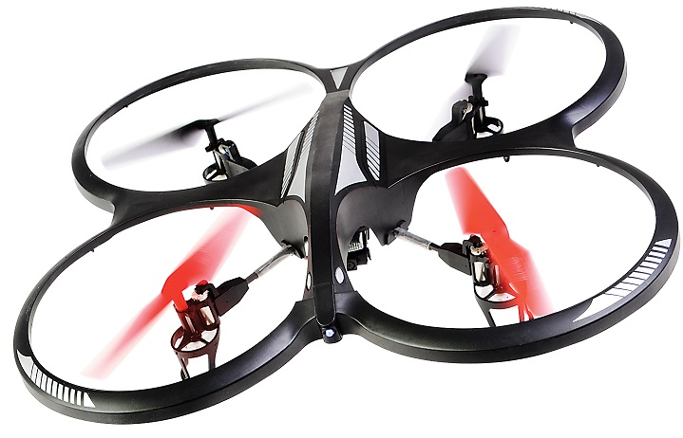












(4) $'s Per Lap Pledges - Online

Each $1 Per
Lap Pledge
Equals 1 Point
for Prizes
Cumulative Prize Program

1 Point - Go To The Mega Party
Jumpies, Hula Hoop, Limbo,
Giant Jump Rope, Music and Prizes
2 Points – Furry Pom Poms
plus, all the above!
3 Points - Emoji or ‘Brown’ Key Chain
plus, all the above!
4 Points – 12 Inch Emoji Pillow
plus, all the above!
6 Points – Fuzzy Emoji Ball
plus, all the above!
8 Points - Squid Hat or Light-Up Bubble Blaster
plus, all the above!
10 Points - Dual Light-up Fan or Poop Hat
plus, all the above!
12 Points - Mega Beat Headphones
plus, all the above!
15 Points - Light-Up Hover Ball
plus, all the above!
20 Points - Virtual Reality Goggles
plus, all the above!
30 Points - Wheel of Fortune
OR, Cyclone of Cash
plus, all the above!
40 Points - Drone with Camera
plus, all the above!

* Example: A $50 Flat Pledge equals 2 points for prizes.

